

User profiles

Activity map

Select IP

All

Status

Ongoing

Select County

All

Show user profiles

Show map

September 22, 2024

**USAID TARGETTING AND LAYERING PLATFORM**

Show leaflet map

Show static map for download download

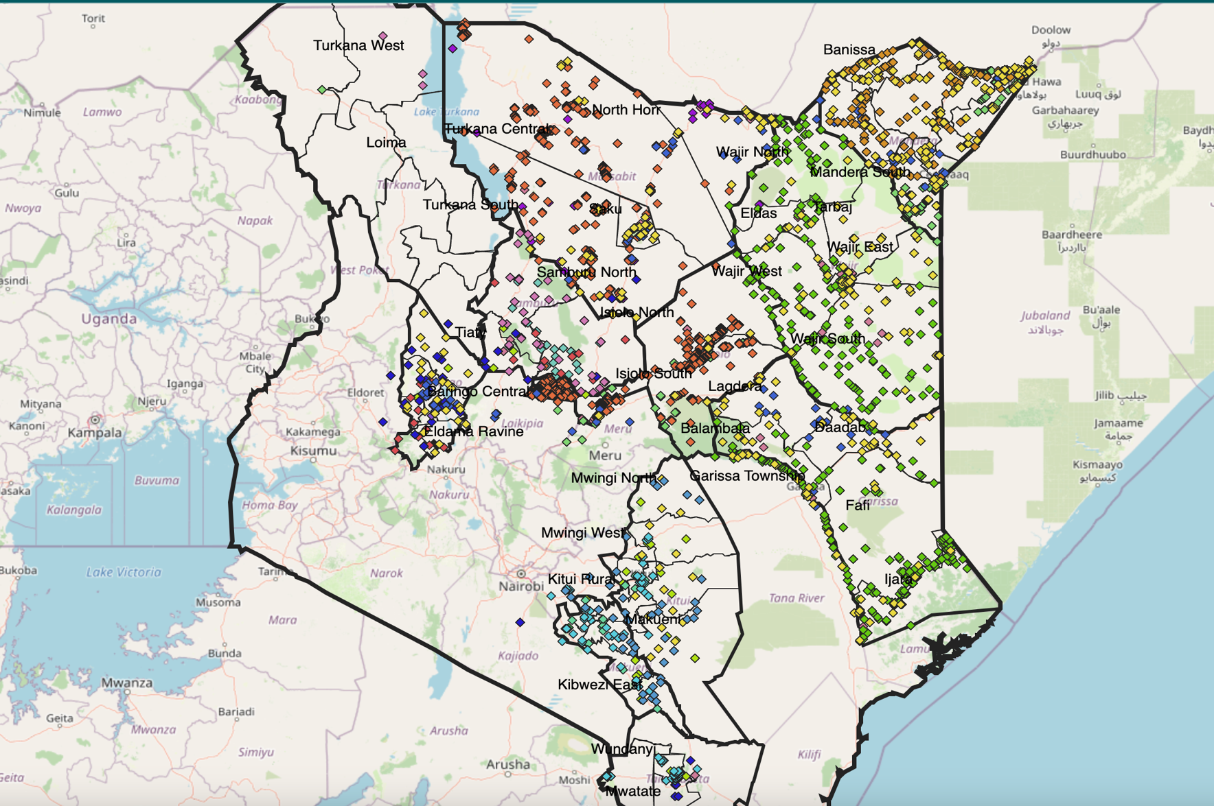

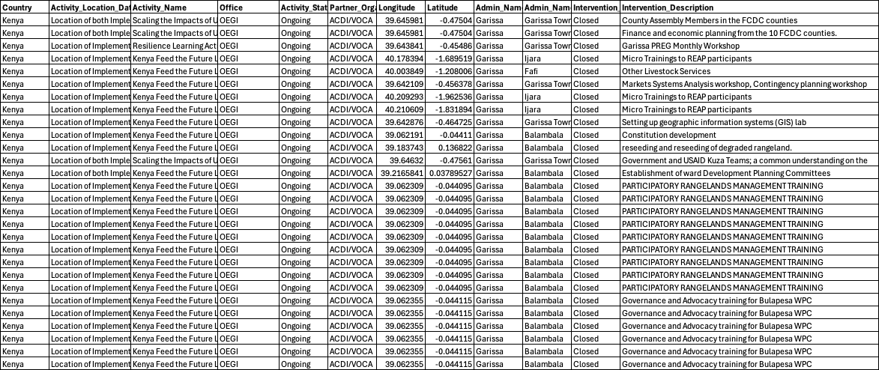

*This Knowledge Management Hub is facilitated by the Resilience Learning Activity, that is USAID funded. For the Partnership for Resilience and Economic Growth (PREG), RLA is the is the secretariat and the leading learning partner. The information provided on this Web site is not official U.S. Government information and does not represent the views or positions of the U.S. Agency for International Development (USAID) or the U.S. Government.*

© 2024 Resilience Learning Activity. Some Rights Reserved.

Search Table

PDF download

Image Download